

**How to Find Your Calling**

**By Dale Callahan, Ph.D., P.E.**

Copyright © 2012, 2013 Dale Callahan



HHooww ttoo FFiinndd YYoouurr CCaalllliinngg

**Welcome to How to Find Your Calling!**

Do you know what you would love to do for a living? Do you know what you are passionate about? Do you know whom you are called to serve?

Your answers to these questions tell an interesting tale. Most people I work with do not have a clear set of answers to these questions. In fact, most people are just clueless.

So if you feel as if you should have a good answer to these questions but do not, take comfort, at least you are not alone. In fact, you are ordinary.

Who wants to be ordinary?

Ordinary is overweight.

Ordinary is broke.

Ordinary is doing a job I do not enjoy.

Ordinary is, well, ordinary.

According to Brian Tracy,

*"One of your greatest responsibilities in life is for you to decide for yourself what you really love to do." I totally agree! Why?*

So why do so many people have no idea of their calling? While I am not going to go into detail here (the book Resumes are Worthless take a deeper look at this question), I will just say that we are never really asked by our teachers, our family, or even ourselves to explore our calling. Instead, we are all put in a box based on our skills.

For me that box went like this. I was good in math and science, so therefore I should be an engineer. When I went to engineering school, I got a coop job (a part time job while in school to get experience) in telecommunications, so I became a telecom engineer. When I went to work full time in telecom, I became a specialist in an area of telecom, so I was an SS7 telecom engineer. The box kept getting smaller and smaller until I was ignorant in most anything else.

Or at least I felt ignorant since I could only get a job in the one thing.

2



HHooww ttoo FFiinndd YYoouurr CCaalllliinngg

But looking back, no one had every really asked me what I loved to do, what I was passionate about, who I wanted to serve. And, I never really asked myself. So, I let myself be put in a box.

**What about you?**

If the story I just told you sounds like you, this is the right book for you to do right now. And note, I said DO and not READ!

This workbook is NOT about the issue of how you got here, or why, but instead it is about helping you find your calling now. It is about you taking action now to define, in writing what you are called to do.

Much of this material has been taken from the book Resumes are Worthless, where I develop the idea of a “Company of One”. The content here is based on chapter 10 of Resumes are Worthless, titled “CEO for you Company of One”.

**Lets get started!**

The following is an edited chapter of Resumes are Worthless

Recently, in a talk I was giving, I shared the various roles that companies have and I asked the group what their “Company of One” was missing. One lady quickly spoke up and said, “I do not have a vision or a strategy.” She could speak for most of us! We all need a vision and a strategy. We need to have some goals that drive us. We need to be working at something we care about and are passionate about. That is what makes work enjoyable.

**DRIVE**

In Daniel Pink’s book, Drive, he explains the way people today are really motivated. While he is talking about motivating employees in his book, it can tell us a lot about motivating ourselves. Having coached hundreds of people directly and thousands indirectly, I can assure you this is what almost everyone wants.

First, we want autonomy. We all want the ability to control our own destinies. We all want the ability to see what needs to be done and to do it. In short, we hate micromanagers. Instead we want leaders who will cast a vision, inspire us to follow them, then get out of our way to let us work our magic.

Second, we want to become experts in what we do. We want the ability to continually learn so our Company of One will have a clear brand: what we uniquely do and what we are very skilled at doing. Whether we are a

3



HHooww ttoo FFiinndd YYoouurr CCaalllliinngg

software developer, a surgeon, or a greeter, we want to be the best and be known for being the best!

Third, we want to be part of something that is meaningful. Nothing is more defeating to the human spirit than to be doing something we believe has no true purpose or meaning. We all want to make a difference and we all want to leave a legacy.

**OF RACEHORSES AND MEN**

But beyond the motivation factor, is really helps if we are doing the right thing—the things we are uniquely created to do. Rick Warren says in his audiocassette, Growing Spiritually at Work, that over 60% of Americans work in the wrong career field. I do not know where he gets his numbers, but my own experience tells me that this really is how most people feel about their work. And if this is true, it spells ‘trouble.’

Ever deal with a spirited racehorse? They are full of tension and quick to spook. They have been bred for action, to play in the race, and make something happen. They cannot wait for the gate to open so they can burst forward. Now can you imagine all that energy tied up giving pony rides to kids? The horse would be a bundle of nerves, and since it is placed in the wrong job, it would be dangerous. Yet, that is how many of us lead our lives—like racehorses giving pony rides!

**ACTION PLAN**

So, how do you get out of this trap, find out what you really want to do, and start making a move to do it? In other words, how do you start being a real CEO to your Company of One?

**CORE**

First, you need to determine your CORE. Over the course of your life, your jobs will change and your careers may change. Even the things you are called to do (your ‘calling’) may change. You may be a medical doctor today and become a farmer later. You may be a software developer who becomes a veterinarian (I know one of these).

A person’s CORE will rarely change (though mine did when I accepted Christ). Your CORE is made up of those things you believe and hold true— those things that guide everything you do. Like the U.S. Constitution, which guides all governmental activity, your CORE is the cornerstone of all your personal and professional decisions. Like the Constitution, if we forget to focus on it, we will drift away from it.

4

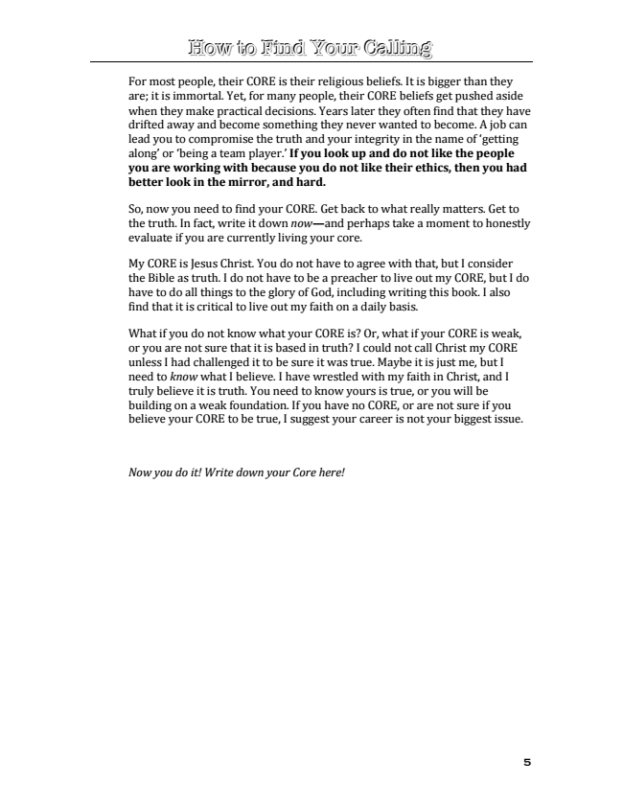

HHooww ttoo FFiinndd YYoouurr CCaalllliinngg

For most people, their CORE is their religious beliefs. It is bigger than they are; it is immortal. Yet, for many people, their CORE beliefs get pushed aside when they make practical decisions. Years later they often find that they have drifted away and become something they never wanted to become. A job can lead you to compromise the truth and your integrity in the name of ‘getting along’ or ‘being a team player.’ If you look up and do not like the people you are working with because you do not like their ethics, then you had better look in the mirror, and hard.

So, now you need to find your CORE. Get back to what really matters. Get to the truth. In fact, write it down now—and perhaps take a moment to honestly evaluate if you are currently living your core.

My CORE is Jesus Christ. You do not have to agree with that, but I consider the Bible as truth. I do not have to be a preacher to live out my CORE, but I do have to do all things to the glory of God, including writing this book. I also find that it is critical to live out my faith on a daily basis.

What if you do not know what your CORE is? Or, what if your CORE is weak, or you are not sure that it is based in truth? I could not call Christ my CORE unless I had challenged it to be sure it was true. Maybe it is just me, but I need to know what I believe. I have wrestled with my faith in Christ, and I truly believe it is truth. You need to know yours is true, or you will be building on a weak foundation. If you have no CORE, or are not sure if you believe your CORE to be true, I suggest your career is not your biggest issue.

*Now you do it! Write down your Core here!*

5



HHooww ttoo FFiinndd YYoouurr CCaalllliinngg

**Calling**

Your calling is what you are called to do. You can take this in a biblical sense or in a DNA sense; it doesn’t matter to me. But clearly, some people are wired to do particular activities and not others. Calling might also be labeled your passion. What are you passionate about? What drives you?

How would you answer the following questions?

What did I want to do when I was a kid?

What kinds of books do I read for fun?

What do I love doing now?

What do I wake up thinking about?

What do I go to sleep thinking about?

What do others ask me to help them do?

Maybe a better question is asked by Ann Rea (you’ll meet her in a minute), “What can I not not do?”

Think about that for a minute. What can you not not do?

Here is how to figure it out for yourself. Write down the answers to the questions above. Do it now. Forget about laboring over each question, just write down what comes to mind. Take as much or as little time as you like, then put the answers away and do the same thing tomorrow. Do this each day for several days. Your mind will be racing all day long on this subject!

I used to tell people to do this differently. I told them to get in a comfortable place and relax. Then get a clean pad of paper and a pen and spend an hour working on this. The problem is, when I would meet with them weeks later, they would not have started to answer these questions because they had not felt they had the time. So just do it now and do something!

CAUTION: Most people will not write down things because just as it comes into their mind they will say to themselves, “I cannot do that” or “you cannot make a living doing that”, etc. Don’t do this! This is a brainstorming exercise. There are no wrong or ‘bad’ answers, so write it all down. You do not have to share this with anyone. Do not challenge your answers (you are not writing a contract; you’re just recording thoughts). Do not let your own thoughts frighten you! Write them down. You never know when a crazy thought might lead you to something exciting.

6

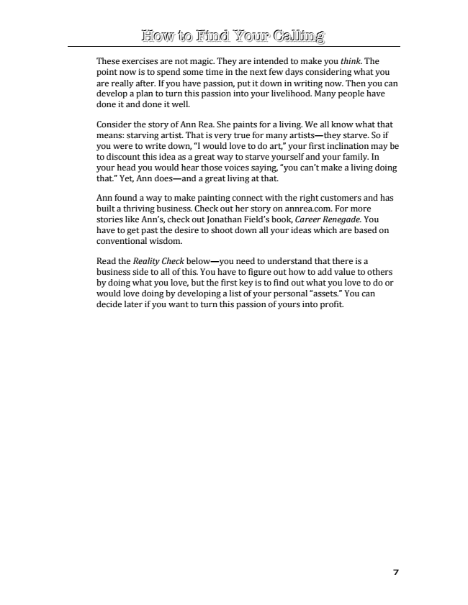

HHooww ttoo FFiinndd YYoouurr CCaalllliinngg

These exercises are not magic. They are intended to make you think. The point now is to spend some time in the next few days considering what you are really after. If you have passion, put it down in writing now. Then you can develop a plan to turn this passion into your livelihood. Many people have done it and done it well.

Consider the story of Ann Rea. She paints for a living. We all know what that means: starving artist. That is very true for many artists—they starve. So if you were to write down, “I would love to do art,” your first inclination may be to discount this idea as a great way to starve yourself and your family. In your head you would hear those voices saying, “you can’t make a living doing that.” Yet, Ann does—and a great living at that.

Ann found a way to make painting connect with the right customers and has built a thriving business. Check out her story on annrea.com. For more stories like Ann’s, check out Jonathan Field’s book, Career Renegade. You have to get past the desire to shoot down all your ideas which are based on conventional wisdom.

Read the Reality Check below—you need to understand that there is a business side to all of this. You have to figure out how to add value to others by doing what you love, but the first key is to find out what you love to do or would love doing by developing a list of your personal “assets.” You can decide later if you want to turn this passion of yours into profit.

7

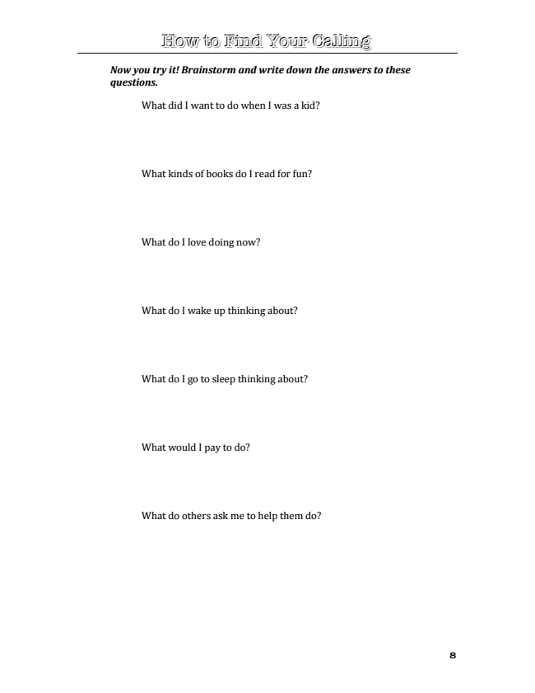

HHooww ttoo FFiinndd YYoouurr CCaalllliinngg

***Now you try it! Brainstorm and write down the answers to these questions.***

What did I want to do when I was a kid?

What kinds of books do I read for fun?

What do I love doing now?

What do I wake up thinking about?

What do I go to sleep thinking about?

What would I pay to do?

What do others ask me to help them do?

8



HHooww ttoo FFiinndd YYoouurr CCaalllliinngg

***CAREER vs. JOB***

OK, have you been thinking about these questions? Have you defined some things you love doing? This step is often a major struggle for people since we are rarely asked what we want. So the temptation is to keep on thinking. We tend to think we need to set aside hours, days, entire vacations just to get to the root of who we are.

If you can do that, great. Do it as soon as possible. But let’s be practical. My experience tells me that people get caught in this struggle trying to “find themselves” for years. Fortunately some finally do, but many just continue to float around in a sea of indecision. So, instead, let’s take action with what you have. After all, you are free to change direction as needed. Trust me, once you start moving in a direction toward what you love doing, you will find it is much easier to change course later if needed.

First, let’s define some terms. Your career is how you make money from your calling, but, it is not a job. For instance, if I love working outside and keeping yards looking wonderful, I might find a career in yard work or landscaping. I did not say a job, but a career.

The job is how I am making money today from the career. So in my landscaping career, I might have a job with A&B Landscapes today. Or if I have gone into business for myself, I might have a job working for Mr. Smith today. In fact, if I am in business for myself I will likely have multiple jobs per day! I may lose one job, but that does not mean I am changing careers.

Dan Miller told me that his coaching has revealed that people do this backwards. They take a job, and after a while it defines them. It is not about what they love, it is just a job. Then when something happens to that job, they question their career and their calling. He has spent years coaching people caught in this crisis. The reason there is a crisis is because they did it all backwards.

Is your current “career” one that came from actually planning to do what you loved? Or, are you like I was: taking the job that was offered and then moving on to the next offer? Suddenly I was defined as a telecommunication expert, but the fact is, I couldn’t really care less about that industry.

OK, enough background. Let’s get to work. This is simple. Take the list of things you love to do (you have written it down, right?) and start writing down ways you can make money doing those things. Do not stop writing until you have at least 20 ideas. If you can only think of one (or none) now, come back to it later. Keep adding to the list over time. Again, once you start thinking about this, your mind will be in overdrive all day. Your antenna will help you see and hear things that look like opportunities.

9



HHooww ttoo FFiinndd YYoouurr CCaalllliinngg

CAUTON: Another caution is in order. Think about how you can get paid doing what you love, not how you can get a job. Forget about jobs and job titles and companies; who cares? You are brainstorming things that people will pay you to do. Again, do not question yourself—just write down your ideas, even if they sound stupid.

A lot of money has been made on “stupid” things. My friend Patrick Cash made over $100,000 from selling building plans for a cat scratching post. Simple? Perhaps. Stupid? If you say so. Patrick will gladly accept either definition. He made six figures on that ‘stupid’ idea. So, go ahead and be stupid.

The trouble with the corporate world is that it has caused many of us to kill our creativity. Patrick, instead of being simple and stupid, was filling a need. He delivered to people a solution to the very problem he himself had encountered—overpriced cat trees.

***Now you do it! Take the list of things you love to do and start writing down ways you can make money doing those things. Do not stop writing until you have at least 20 ideas.***

10